[Title Page]
[Table of contents]
PART 1
Installing

[NB:] I'm using Android Studio 2.2.3 and FTC packet version 2.4 (released on 6/11/13)
Installing Android Studio
So the first thing you need to do is install Android Studio. Android Studo is an Integrated Development Environment (IDE) for the programming language Java. It checks your code for bugs in realtime. Programming without it would mean that you would only be aware of bugs after compiling it.
1. Download the Android Studio Installer
The first few steps are pretty simple, but I'll go through them anyway. Go to https://developer.android.com/studio/index.html and download the installer. The page should look
like this:
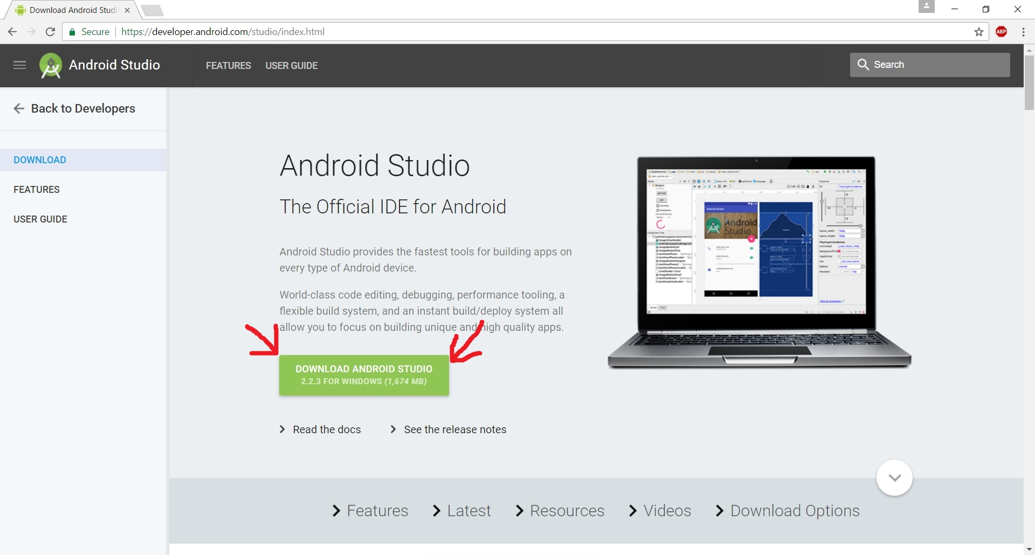
2. Run the installer
Choose the IntelliJ theme. Then the photos I have will look the same as what you're looking at. Don't install the emulator, you won't need it.
3. Install the correct SDKs
And SDK is a System Development Kit. It gives you the tools to work with a certain system. So like, if Java is the tool box, and SDK is like the kit with the drill and drill bits.
3.1 Open the Standalone SDK Manager
Android Studio has many SDKs you can install. They corrospond with the different Android operating systems. FTC has limits on which phones they allow, and by extension, which operating systems they allow. So you don't have to install the SDKs for every Android operating system. The different SDKs are grouped by what are called APIs, or Application Programming Interfaces. These are numbered, which makes them a good way to differentiate SDK packages.
For FTC you need the entire API 19 package, the entire API 21 package, and a few select packets from API 23 and 24.
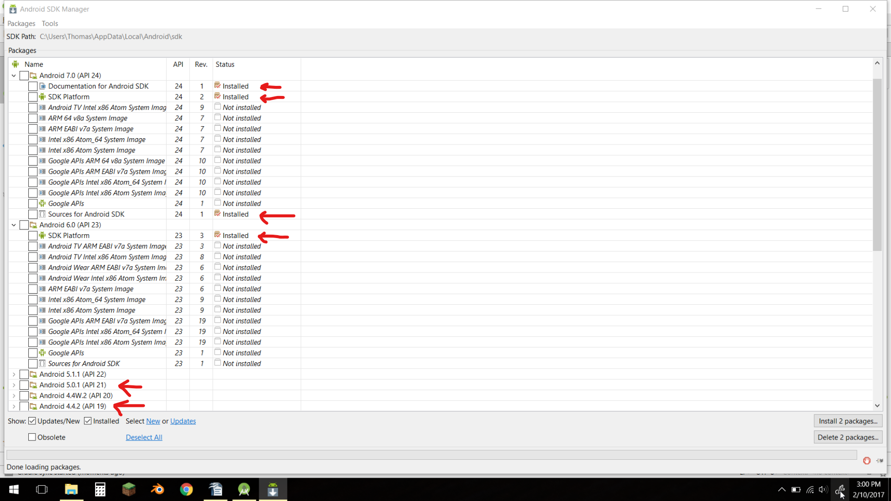
So check them all and click install. Then go get lunch, this will take a while.
Next we'll go over the installation of the FTC package itself.

Installing the FTC Packet
The FTC packet allows you to program FTC opmodes in Android Studio. It comes as a Gradle project you have to import. This is tricky, everything has to be just-so.
1. Download the FTC Packet
Go to https://github.com/ftctechnh/ftc_app. You can also google "FTC Android Studio Packet" and that will turn it up as well. It should look like this:
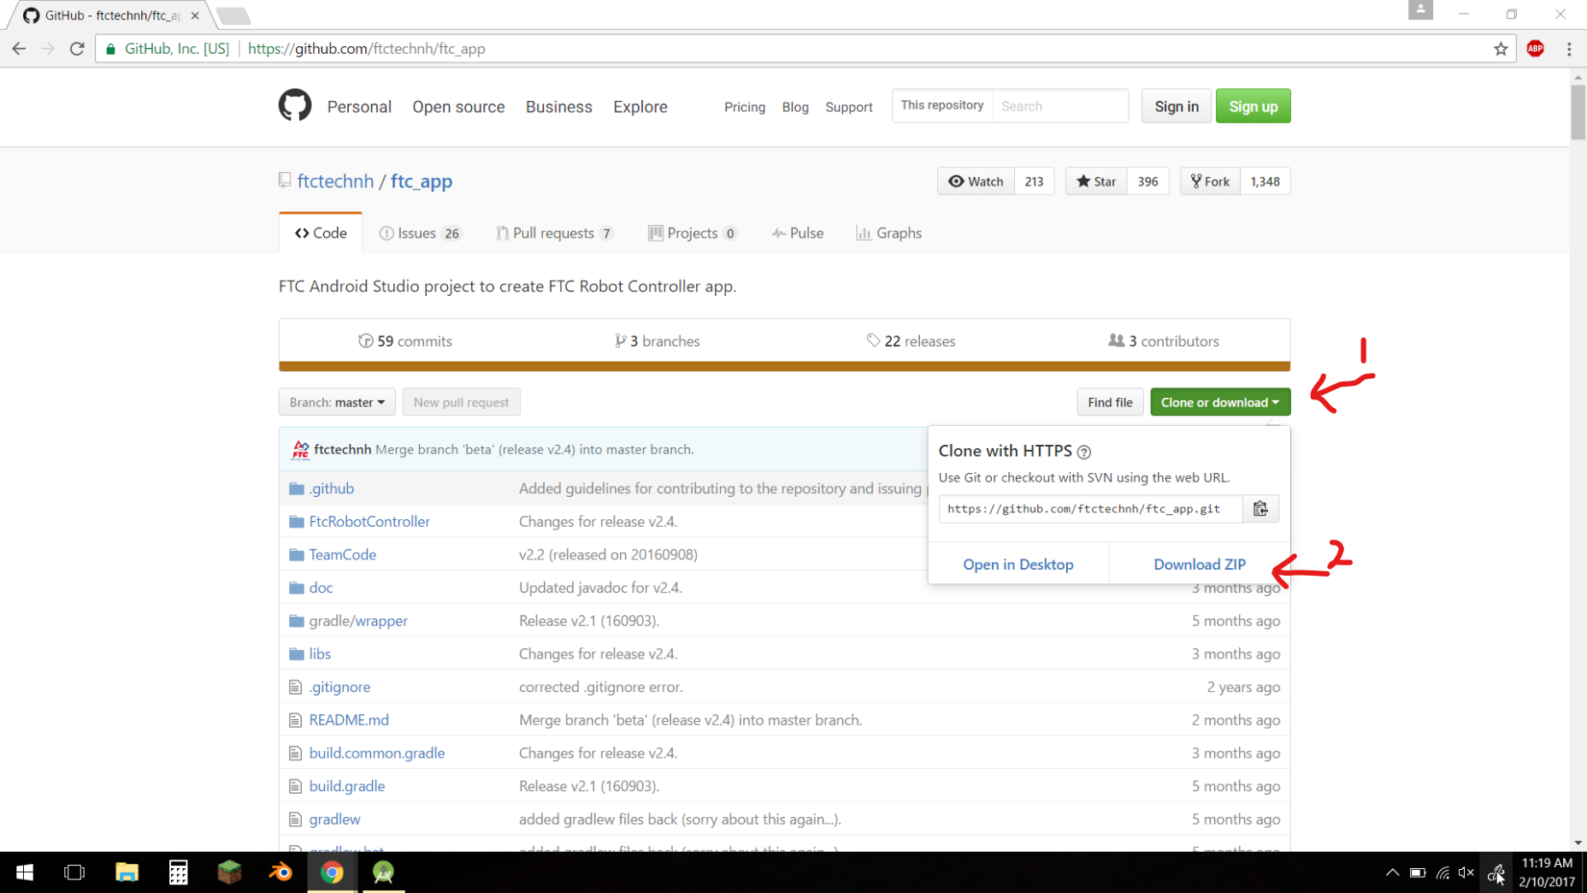
So click on "Clone or download," then clock on "Download ZIP." Note where you download it to. Navigate to the zip file and extract it.

It'll look like this:
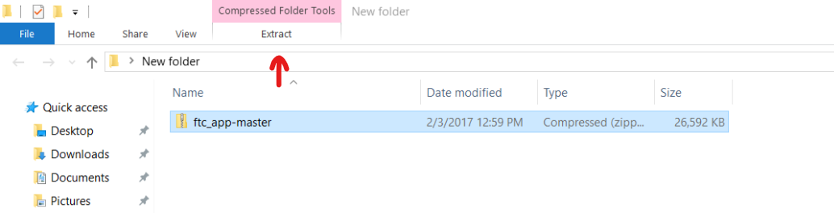
Click the Extract button. Once that's done return to Android Studio.

2. Import the FTC Packet to Android Studio
In Android Studio, you should be looking at a window like this:
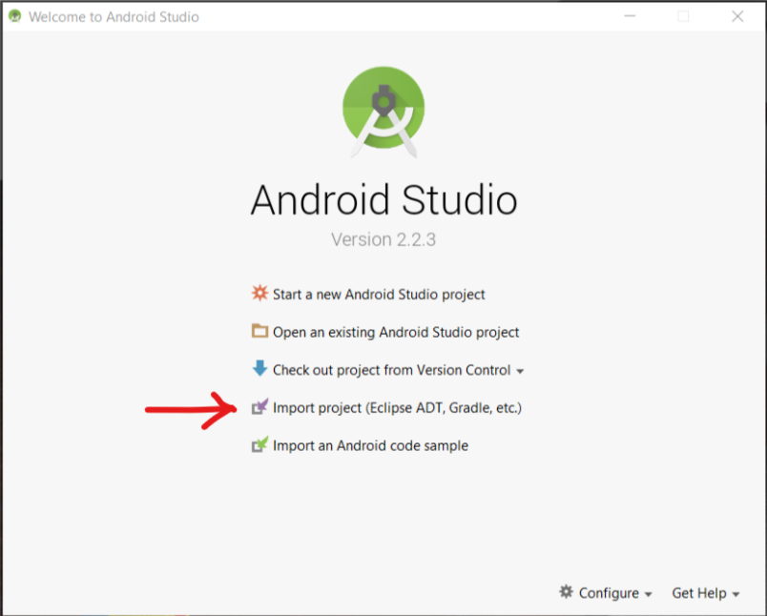
If you aren't, you're looking at a project already. Go to the top left corner and click File, then Close Project in the dropdown menu. Then click Import Project(Eclipse ADT, Grade, etc.). Find the extracted FTC folder and click open.
Beware: There is a second identical folder nested just beneath it. DON'T SELECT IT. Select the topmost folder named ftc_app_master. Then click import. It will look like this:
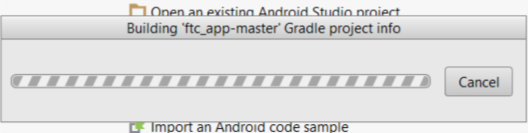
It will do that for a while, and then Android Studio should open fullscreen. Don't click anything yet, though, because it's still working in the background. Look at the bottom of the screen:
You might get an error that looks like this:
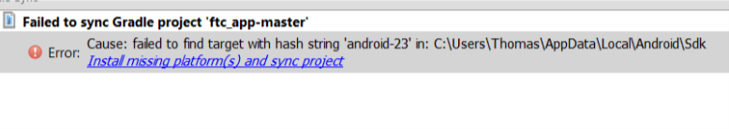
Click the link and wait for it to finish. You may have to do this multiple times.
Once it's done and you haven't gotten any errors, look over at the left side of your screen. There will be tabs on the side. One of them is labelled Project. Click on it. You should get a pop-out. Expand the FtcRobotController, copying the image below.
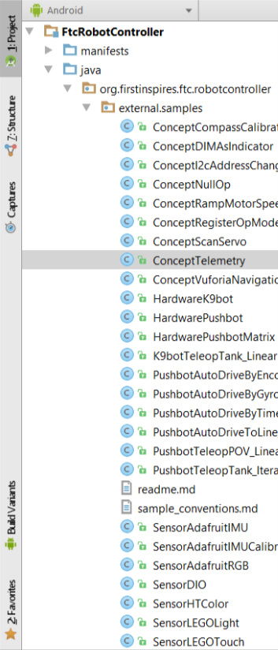
What you're looking for is the little blue C icons. Congratulations! Android Studio is now succesfully installed on you computer.
Now, there are two folders in the Project tree, FtcRobotController and TeamCode. FtcRobotController is where all the samples are, and TeamCode is where your code will go. You can only load programs from the TeamCode folder onto the phones. Most of the programs have very minimal documentation, so they are very hard to understand. Because of that, some sample programs have been included with this manual to help you along.
PART 2
Understanding FTC
Hardware Maps
The first thing you need to know about FTC programming is that there are two different kinds of programs. There are Hardware maps and Opmodes. Opmodes are the actual programs. They take input from the gamepads and sensors and send power values to the motors. Hardware maps are, quite literally, maps of the hardware. They inform the opmodes where the motors and sensors are.

The HardwarePushbot is a good example of this.
The first three lines looks like this:

package org.firstinspires.ftc.robotcontroller.external.samples;

import ...

If you click the little black plus just in front of the import line it will expand into this:

import com.qualcomm.robotcore.hardware.DcMotor;
import com.qualcomm.robotcore.hardware.HardwareMap;
import com.qualcomm.robotcore.hardware.Servo;
import com.qualcomm.robotcore.util.ElapsedTime;
These are all required for the Hardware map to work. Don't worry about them though, just be aware that they are there and don't touch them.
Looking farther down, you see these lines:

public class HardwarePushbot
{

This starts the Hardware map. Everything inside the curly brackets is part of the map.
The first few lines of the program look like this:

public DcMotor leftMotor = null;
public DcMotor rightMotor = null;
public DcMotor armMotor = null;
public Servo leftClaw = null;
public Servo rightClaw = null;
This code block declares the motors that will be on the robot.

public DcMotor leftMotor = null;

This line declares that there is a DcMotor motor called leftMotor. One important thing to note is that in your opmodes this motor always has to be referred to as leftMotor. This is case-sensitive, by the way, if you refer to it as LeftMotor it won't work.

public Servo leftClaw = null;

This line declares that there's a servo named leftClaw.
The next three lines look like this:

public static final double MID_SERVO = 0.5 ;
public static final double ARM_UP_POWER = 0.45 ;
public static final double ARM_DOWN_POWER = -0.45 ;
These define variables that will never change and can be used in all the programs that use this hardware map. Ordinarily for programming you would use int or float to define a variable, but for some reason it works better if you use double.

HardwareMap hwMap = null;
private ElapsedTime period = new ElapsedTime();
These lines set up the hardware map itself and set some groundwork for the sleep cycle, which will be explained later.

public HardwarePushbot(){
}
This is a placeholder. Java has very specific rules about how programs are set up, and this essentially legalizes the program in Java's eyes.

public void init(HardwareMap ahwMap) {

This starts the part of the program that actually defines the hardware map. The hardware map is a little complicated as it involves the computer, the robot controller phone, and the robot's wiring.

The hardware map is a big hierarchical structure that defines where motors and sensors are. It looks basically like this:
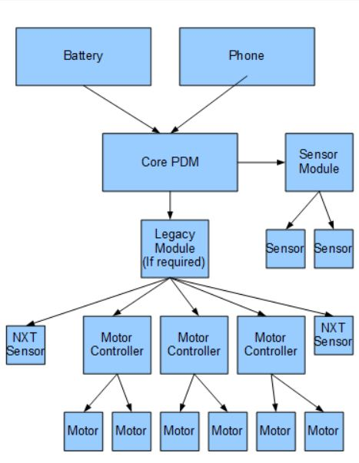
This map is on your phone. Each motor and sensor is assigned a name, and the hardware map program on your computer uses those names to locate the motors and sensors. The hardware map can then assign them different names that the opmodes will use. We'll go through setting up a harware map later.

hwMap = ahwMap;

You can ignore this line. Don't delete it, but don't change it, either. A lot of things in these programs are things simply to be left alone.

leftMotor = hwMap.dcMotor.get("left_drive");
rightMotor = hwMap.dcMotor.get("right_drive");
armMotor = hwMap.dcMotor.get("left_arm");
These lines are assigning names to motors. The words in quotes are the names on the hardware map that the phone has. The names at the beginning is what the opmodes will use to refer to the motors. The parts in the middle are the commands. They're pretty simple to read.

leftMotor.setDirection(DcMotor.Direction.FORWARD); \
rightMotor.setDirection(DcMotor.Direction.REVERSE);
These lines set the direction the motors will consider forward. Forward is clockwise as you look at the motor axle on. Reverse is anti-clockwise from axle on.

leftMotor.setPower(0);
rightMotor.setPower(0);
armMotor.setPower(0);
The program then sets all the motors to 0 power. This is to ensure that none of them move during initializing and that they start in a neutral state.

leftMotor.setMode(DcMotor.RunMode.RUN_WITHOUT_ENCODER);
rightMotor.setMode(DcMotor.RunMode.RUN_WITHOUT_ENCODER);
armMotor.setMode(DcMotor.RunMode.RUN_WITHOUT_ENCODER);
These lines state that the motors have no encoders attached to them, so that the opmodes don't try to read from them. What this means is that you will have to use time to guide your robot in autonomous.

leftClaw = hwMap.servo.get("left_hand");
rightClaw = hwMap.servo.get("right_hand");
leftClaw.setPosition(MID_SERVO);
rightClaw.setPosition(MID_SERVO);
These lines do it all over again but for servos. If we go back to the place where the variables defined we find: public static final double MID_SERVO = 0.5;
Servos work on a scope of position. They all have encoders, and the encoders are used to position them at certain places. So 0.5 is in the middle.

public void waitForTick(long periodMs) {
long remaining = periodMs - (long)period.milliseconds();
if (remaining > 0) {
try {
Thread.sleep(remaining);
} catch (InterruptedException e) {
Thread.currentThread().interrupt();
}
}
period.reset();
These lines eat up time while the hardware maps waits for another cycle to come around. They're another don't touch zone. It'll do its thing and as long as you don't mess with it it won't mess up.

That's the hardware map. Next we'll go over the anatomy of an opmode.

Opmodes

The best and simplest example of an opmode is PushbotTeleopTank_Iterative. The first several lines are copyright stuff. Luckily it is compacted by default. The first line of actual code is
package org.firstinspires.ftc.robotcontroller.external.samples;

Just like in the Hardware map, you don't have to pay much attention to this. Just don't touch it.

import com.qualcomm.robotcore.eventloop.opmode.Disabled;
import com.qualcomm.robotcore.eventloop.opmode.OpMode;
import com.qualcomm.robotcore.eventloop.opmode.TeleOp;
import com.qualcomm.robotcore.hardware.DcMotor;
import com.qualcomm.robotcore.hardware.DcMotorSimple;
import com.qualcomm.robotcore.robot.Robot;
import com.qualcomm.robotcore.util.Range;
These also don't need to be touched. If you're going to build your own opmode from scratch, you'll want these. If you copy an opmode, they'll copy along and you can leave them condensed.

@TeleOp(name="Pushbot: Teleop Tank", group="Pushbot")
@Disabled
The @TeleOp indicates that this is a teleop opmode. The (name="Pushbot: Teleop Tank", group="Pushbot") means that the name will show up on the phones as Pushbot: Teleop Tank and it will be in the group Pushbot. All the opmodes in the same group will show be listed next to each other, with the groups seperated by thicker lines between them. The @Disabled means that this program won't show up on the phone. If you want your program to show up, just comment it out.

public class PushbotTeleopTank_Iterative extends OpMode{

This line begins the opmode as a whole. The name there, PushbotTeleopTank_Iterative must match your program name EXACTLY. It's case-sensitive too, so be aware of that.

HardwarePushbot robot = new HardwarePushbot();

This line declares the object robot as a new example of the hardware map. This allows the opmode to reference the motors and sensors defined in the hardware map.

double clawOffset = 0.0 ;
final double CLAW_SPEED = 0.02 ;
These lines just define certain variables.

@Override
public void init() {
This begins a code block that will run once when the driver hits init on the driver phone. If you had servos that should be moved to a certain position before the match, this is where you would put the code for it.

robot.init(hardwareMap);

telemetry.addData("Say", "Hello Driver");
}
The first line initializes the hardware map, setting it up for being referenced. The second line sends information from the robot phone to the driver phone. You can set it to be dynamic, as we'll go over later, but in this instance it is just a string message.

@Override
public void init_loop() {
}
If you had anything that you wanted looped over and over while you were waiting to hit the play button this is where you would put it.

@Override
public void start() {
}
If you had any code to be run once when you hit start this would be the place for it.
All these loops are noted in the code comments, I included them here so I wouldn't have skipped three loops without warning.

@Override
public void loop() {
This is the meat and potatoes of the opmode. The code in this loop will repeat until you press stop.

